

Group Project Plan

Module Code: COMP50074
Module name: PROFESSIONAL PRACTICE AND PROJECT MANAGEMENT

Student names and CB numbers for all group members:

What is proposed?
Provide a problem statement:

Project Objective | Deliverable

Who are the End Users? How Does your solution address their needs?
End User | How your solution addresses their needs

User Personas – Identify personas for your end users

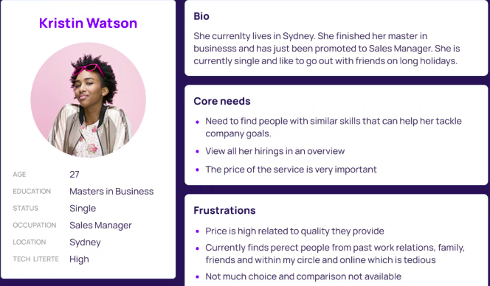
E.g.

